 ÇUKUROVA UNIVERSITY

ENGINEERING AND ARCHITECTURE FACULTY

DEPARTMENT OF COMPUTER ENGINEERING

GRADUATION THESIS

ELECTRONIC PARTS SALES E-COMMERCE WEBSITE

By

2019556063 – Mert VURAL

By

2018556009 - Hüseyin BABACAN

Associate Professor Serkan KARTAL

<https://github.com/Mertvurall/tez>

June 2024

ADANA

Contents

ABSTRACT . . . . . . . . . . . . . . . . . . . . . . . . . . . . . . . . . . . . . . . . . . . . . . . . . . . . . . . . 3

INTRODUCTION . . . . . . . . . . . . . . . . . . . . . . . . . . . . . . . . . . . . . . . . . . . . . . . . . . . . 4

DEVELOPMENT PHASE

1.Design Of The Websit On Paper . . . . . . . . . . . . . . . . . . . . . . . . . . . . . . . . . 5

2. Database Design . . . . . . . . . . . . . . . . . . . . . . . . . . . . . . . . . . . . . . . . . . . . .5

3. Used Libraries . . . . . . . . . . . . . . . . . . . . . . . . . . . . . . . . . . . . . . . . . . . . . . . 6

THE UTULITISATION OF THE WEBSITE

1. The Process Of Placing An Order . . . . . . . . . . . . . . . . . . . . . . . . . . . . . . . . 8

2. Using The Admin Panel . . . . . . . . . . . . . . . . . . . . . . . . . . . . . . . . . . . . . . .10

I. User section . . . . . . . . . . . . . . . . . . . . . . . . . . . . . . . . . . . . . . . . . . .10

II. Category . . . . . . . . . . . . . . . . . . . . . . . . . . . . . . . . . . . . . . . . . . . . . 12

III.Dealer . . . . . . . . . . . . . . . . . . . . . . . . . . . . . . . . . . . . . . . . . . . . . . . 14

IV. Products. . . . . . . . . . . . . . . . . . . . . . . . . . . . . . . . . . . . . . . . . . . . . 16

V. Orders . . . . . . . . . . . . . . . . . . . . . . . . . . . . . . . . . . . . . . . . . . . . . . .18

VI. Reports. . . . . . . . . . . . . . . . . . . . . . . . . . . . . . . . . . . . . . . . . . . . . .19

3 Uploading Data And Activating The Site . . . . . . . . . . . . . . . . . . . . . . . . . . .20

Thanks To . . . . . . . . . . . . . . . . . . . . . . . . . . . . . . . . . . . . . . . . . . . . . . . . . . . . . . . . .21

Referances . . . . . . . . . . . . . . . . . . . . . . . . . . . . . . . . . . . . . . . . . . . . . . . . . . . . . . . .21

ABSTRACT

The objective of this project and this paper is to develop an e-commerce site utilising the ASP.Net, MVC structure and layered architecture. The aim is to provide optimal accessibility on the administrative interface of the e-commerce site, including users, products, categories of products, subcategories of these categories and created orders. Furthermore, this e-commerce site comprises three distinct categories of members: administrators, end users, and contracted wholesale buyers. It is intended that each product will be priced differently for each of these categories.

INTRODUCTION

In recent years, the number of e-commerce sites has continued to increase at a rapid pace. One of the main reasons for this is the development of technology and the fact that almost everyone is engaged in trade, whether for the purpose of increasing their earnings or of marketing their handicrafts to people. Regardless of their reasons, each of them needs a site for this. The construction of this website was undertaken utilising Microsoft APS.NET MVC 5.0 C#. The rationale behind this choice was that MVC is an up-to-date and fast structure, while at the same time being easy to understand. ASP.NET is secure, and it is possible to increase its security to a high level with a few libraries. Microsoft SQL Server Management Studio was employed in the database section. The straightforward installation and user-friendly interface afforded us the convenience we required during the initial stages of the project's development.

DEVELOPMENT PHASE

1.Design Of The Websit On Paper

Firstly, a decision was made regarding the functionality of the website, the content it would host and the manner in which it would operate. The website utilises the ASP.NET MVC structure, which facilitates the sale of electronic components. It was determined that the website would comprise an administrative panel, a dealership area and an end-user membership section. The administrators would have the authority to open the end-user membership section and there would be a price differential between dealers and end-users.

2. Database Design

A total of six tables were created for the database, namely Dealers, Order Card, Products, Order Movements, Users, and Categories. In the ‘Kullanicilar’ table, the user group is determined. This group determines whether the user is an administrator, an end user, or a dealer. If the user is a dealer, the user is created. The ‘Bayiler’ table contains the ID of the dealer in our database, the code of the dealer, the title of the dealer, the representative of the dealer and the password required for the dealer representative to log in to the site. The ‘Kategoriler’ table comprises two categories, as illustrated in Figure 1.1 . In our ‘Urunler’ table, we have included images of the products and descriptions of the products, as well as two prices, ‘UrunFiyat’ and ‘UrunBayiFiyat’ . The price displayed to end users and non-logged in users is designated as ‘UrunFiyat’ , while the price for dealers is designated as ‘UrunBayiFiyat’ . The final two tables relate to orders. The ‘SiparisKart’ table contains the total mail of the order received, along with the information of the buyer who placed the order. This is presented in a single line. The ‘SiparisHareket’ table is the detailed version of the order lines in the ‘SiparisKart’ table. It contains information such as the number of each product in the order, the price, and the buyer.

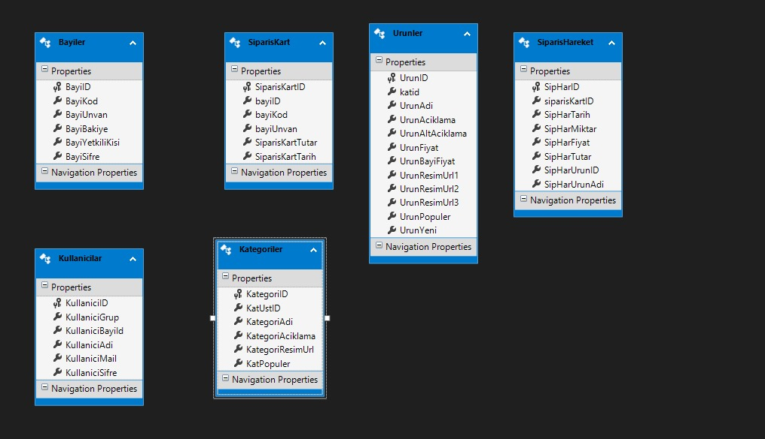 Figure 1.1 Database Design

3. Used Libraries

In this project, the OWIN library was employed for security and user roles, while the AJAX library, Bootstrap library, toast and swal from sweet alert library were utilized for notifications. The Entity Framework library was leveraged. The business library, which was created for the database, was utilized, and it contains various helpers. The summernote library was employed for the description section in the products in the admin panel. The data on the report page was visualised using Chart.js. Finally, the UrlHelpers were utilized to create links in the routelines for our own work. The UrlHelpers class provides the functionality to create friendly URLs for Google SEO.

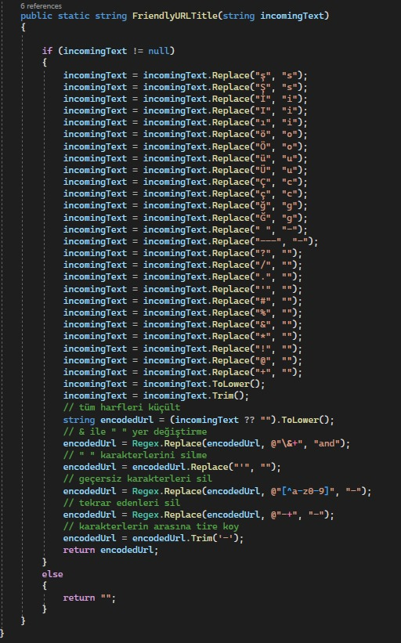

Figure 2.1 Helpers

THE UTULITISATION OF THE WEBSITE

1. The Process Of Placing An Order

In order to place an order, you must first log in. This is done by clicking on button 1 or button 2 in figure 3.1 . If the person logging in is a dealer representative, they should click on button 1. if they are an end user, they should click on button 2. they will then be logged in by entering their login details on the page that opens. If they are not logged in, they can continue to add to the basket, but cannot purchase. If they are not logged in, they will be able to continue adding to the basket, but will not be able to make a purchase. If the logged in person is an admin, they will be taken to the admin panel. If the logged in person is a dealer or end user, they will be taken to the home page. To see the categories of products sold in the shop, press button number 3 in figure 3.1, then the upper categories will appear on the screen that opens, each of the upper categories has its own subcategories, once the desired category is found, select the desired one from the button group number 5. Then a screen as in figure 2 will appear. Then you can add the product to your shopping basket by pressing the "buy" button in the middle of the small icons or by going to the detail page of the product (figure 3.3). If there is no item in your shopping basket, the "buy" button will be inactive (figure 3.4, button 5). You can adjust the quantity of products in your shopping basket by pressing the button number 1 in figure 3.4. 4. If you reduce the number of products in the basket, while the number of products is 1, the product will be removed from the basket. You can also do the same by pressing the button number 2 in figure 3.4 . You can see the unit price of the products in the basket in column 3, and the total amount in column 4.

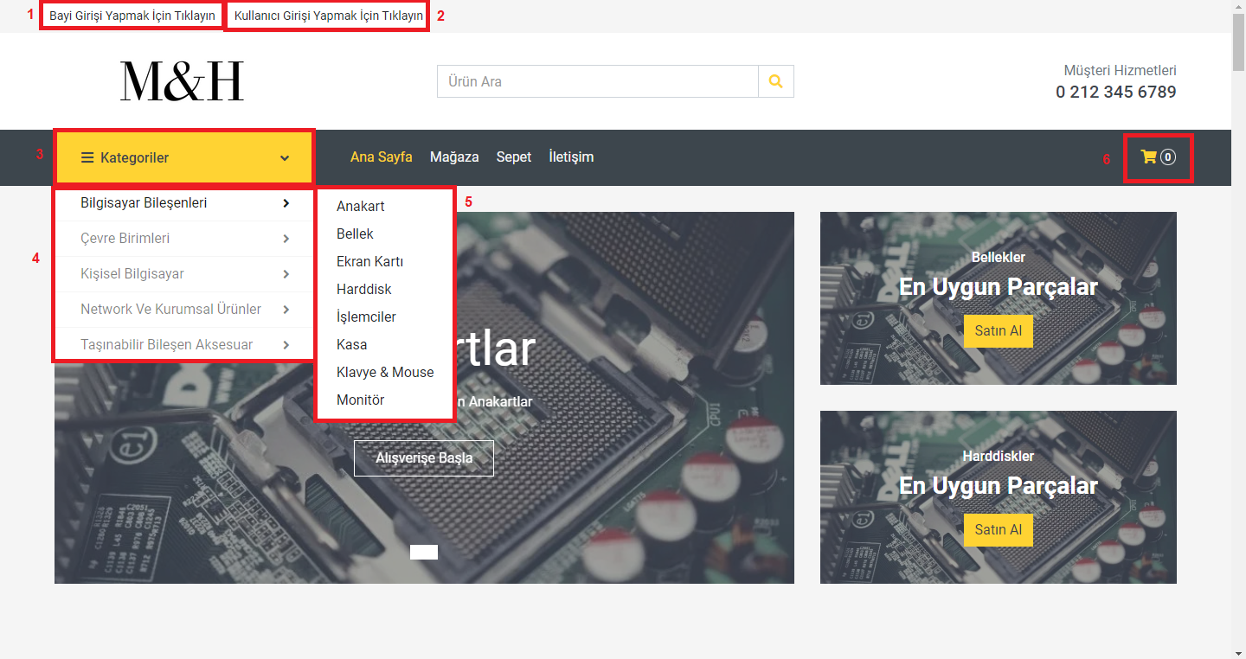 Figure 3.1 Home Page

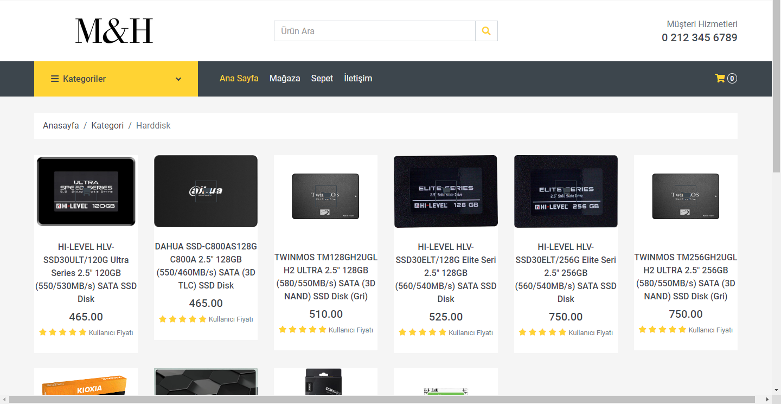 Figure 3.2 Category Page

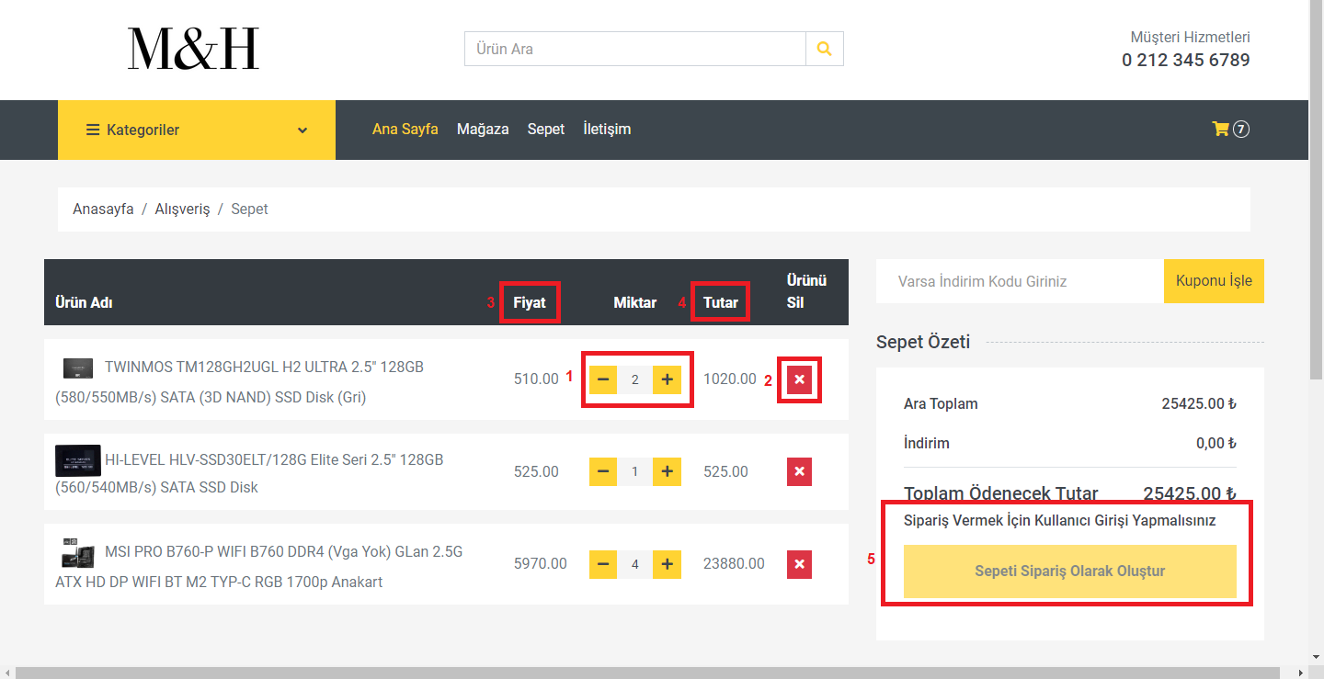 Figure 3.4 Basket

2. Using The Admin Panel

I. User Section

When the user logs in to the admin panel, a screen like the one in figure 4.1 appears in front of the user, this screen lists all the users registered on the site. This screen is designed to be very simple and easy to use. Button 1 in figure 4.1 takes the user to figure 4.2, which is a new user add page. On the new user add page, a new user can be added in 6 steps. In the first input field, the user's group should be specified, here the user's group is selected from admin, end user, dealer. If the person to be added is a dealer, the dealer represented by the person is added in the second step. If the person is not a dealer, the second input field should be left blank. The user's email address is entered in the 3rd field, the user's name in the 4th field and the user's password, which the user will use to access the site, in the 5th and last field, and then the user is added with the Submit button, which is button number 6.

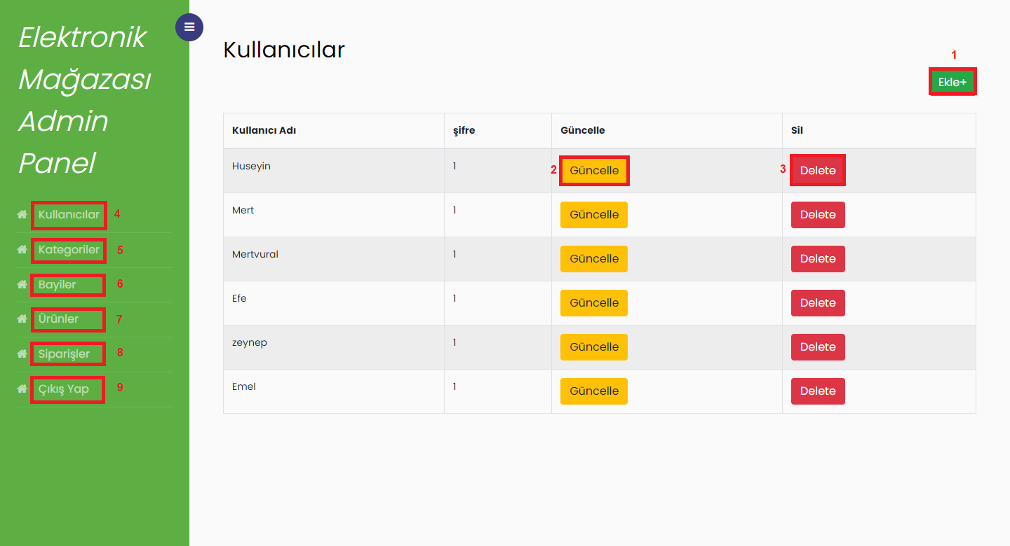 Figure 4.1 Admin Panel User Page

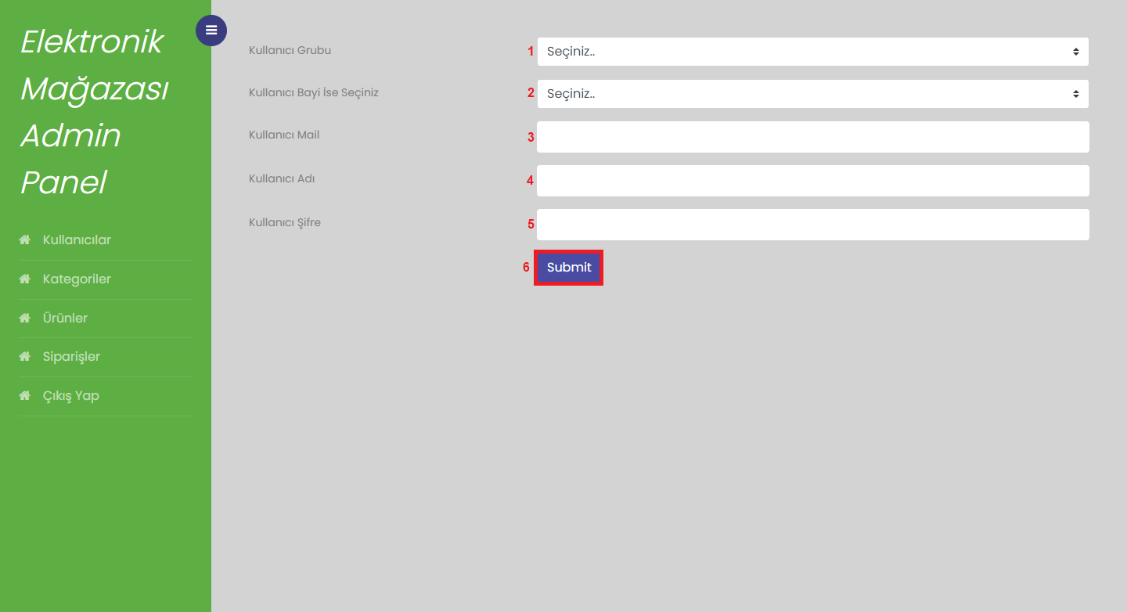

Figure 4.2 Admin Panel New User Add Page

II. Category

In order to access the categories page, it is necessary to press button 5, as shown in figure 4.1. This page contains three buttons (figure 5.1), which are labelled 1, 2 and 3. Button 1 is used to add a new category, button 2 is used to update an existing category, and button 3 is used to delete a category.

Upon pressing button 1 to add a new category, a screen similar to figure 5.2 is displayed. In this screen, the name of the category is entered in the input field labelled number 1. In the input field labelled number 2, the user selects whether the category is a main category or a subcategory of a main category. If it is a main category, the user can see the category that was previously added as the main category in the input field labelled number 2 during each new category to be added after the registration process is finished and add new subcategories under it. (Figure 5.3: Fields 1 is the main category, fields 2 is the subcategory). In field 3, a brief description of the category can be added if desired. The checkbox in field 4 indicates whether the category will appear in the main menu or not. If the category is a main category, it is recommended to select field 4. In step 5, it is requested that a photograph be entered to represent the category. In step 6, the process of adding the category is saved.

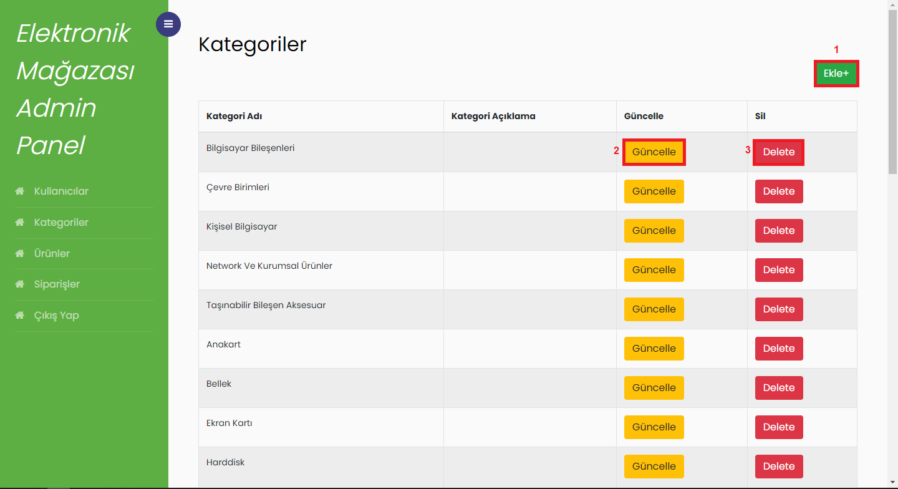

Figure 5.1 Admin Panel Category Page

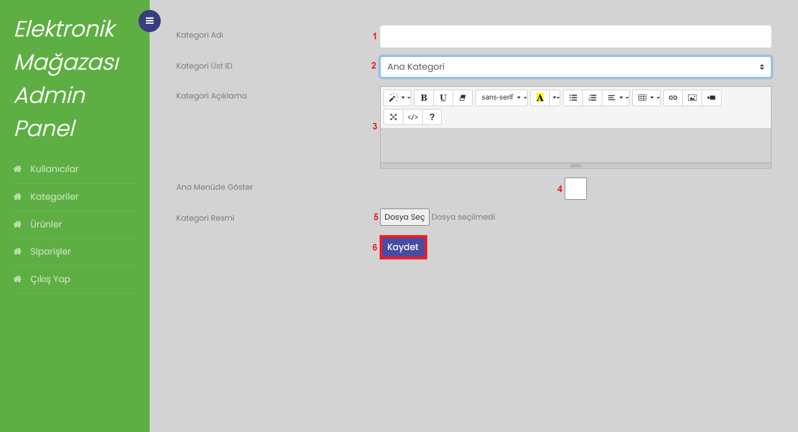 Figure 5.2 Admin Panel New Category Add Page

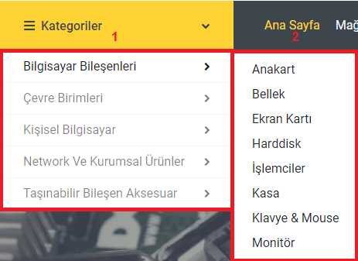

Figure 5.3 Category Hierarchy

III.Dealer

In order to access the dealers, it is necessary to press the third button on the navigation bar, as shown in Figure 4.1 (Figure 4.1 button 6). This will result in the appearance of a page containing the dealers registered in the database (Figure 6.1). As shown in Figure 6.1, three buttons are displayed on this page: the first of which is button 1, which takes the user to the page for adding new dealers, button 2 to update an existing dealer and button 3 to delete the selected dealer.

Upon pressing button 1, the user is directed to figure 6.2, which is the new dealer addition page. This page allows the addition of a new dealer in five steps. The first step is to enter the code of the dealer in input 1. The second step is to enter the title of the dealer in input 2. The third step is to enter the name of the authorised person who will represent the dealer in input 3. The fourth step is to enter the name of the authorised person who will represent the dealer in input 4. Finally, the password required for the dealer login should be entered in input 4. Once all the required information has been entered, the registration process is completed by pressing button 5. It should be noted that the information in question can be modified at any time via the button labelled "2" in Figure 6.1.

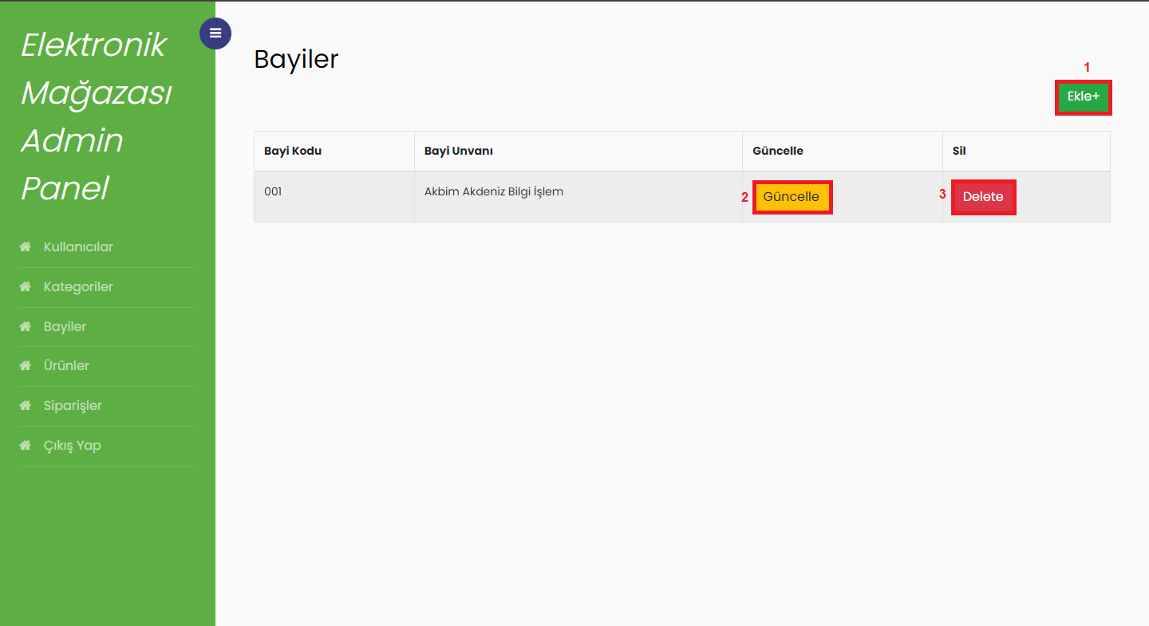 Figure 6.1 Admin Panel Dealer Page

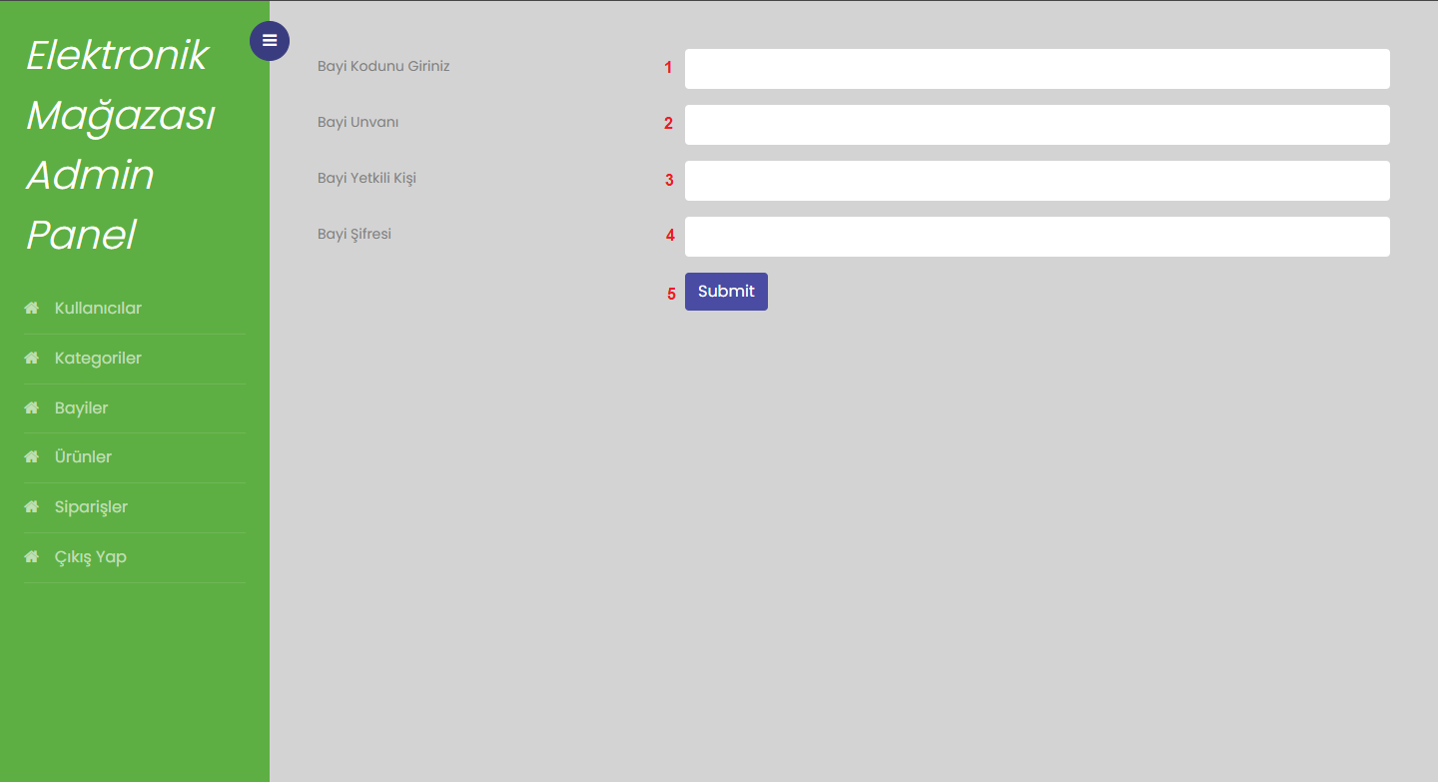 Figure 6.2 Admin Panel New Dealer Add Page

IV. Products

In order to access the products menu, it is necessary to press button 4 (button 7 in Figure 4.1) from the navbar. Once this has been done, the menu with the products in our database will be displayed. It should be noted that there are two different price information on this screen. The price displayed in box number 4 in Figure 7.1 is the price that will be visible to the end user and users who are not registered on the site. In contrast, the price displayed in box number 5 in Figure 7.1 represents the price only for dealers.

The button labelled "1" in Figure 7.1 directs the user to the page where new products are added. The button labelled "2" should be pressed to update existing products or change their data, while the button labelled "3" should be pressed to delete an existing product.

Upon pressing the button labelled "1" in Figure 7.1, which is used to add a new product, the user will be directed to the page depicted in Figure 7.2. On this page, it is possible to upload the product to the site in 12 steps. Firstly, as illustrated in Figure 7.2, the user must enter the name of the product in input 1, the category to which the product belongs in input 2, and the description of the product in input 3. The information entered in input 3 will appear under the product under the name "Product features." In the fourth input, provide a brief description of the product, using abbreviations where appropriate. In the fifth input, enter the price at which the product will be displayed to end users and unregistered users. In the sixth input, enter the special price of the product for dealers. In the seventh checkbox, indicate whether the product is popular. Should the seventh step be selected, the product will be included among those deemed popular on the homepage. In the eighth checkbox, the user can indicate whether the product is new to the site. Should the eighth checkbox be selected, the product will be displayed among the new products on the home page, and a new icon will be added to indicate this. In steps 9-10-11, images associated with the product are uploaded to the system. Finally, in step 12, the product is uploaded to the system.

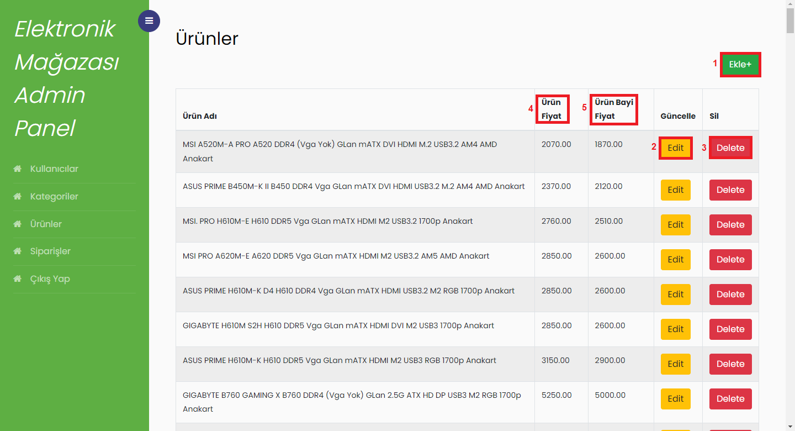 Figure 7.1 Admin Panel Products Page

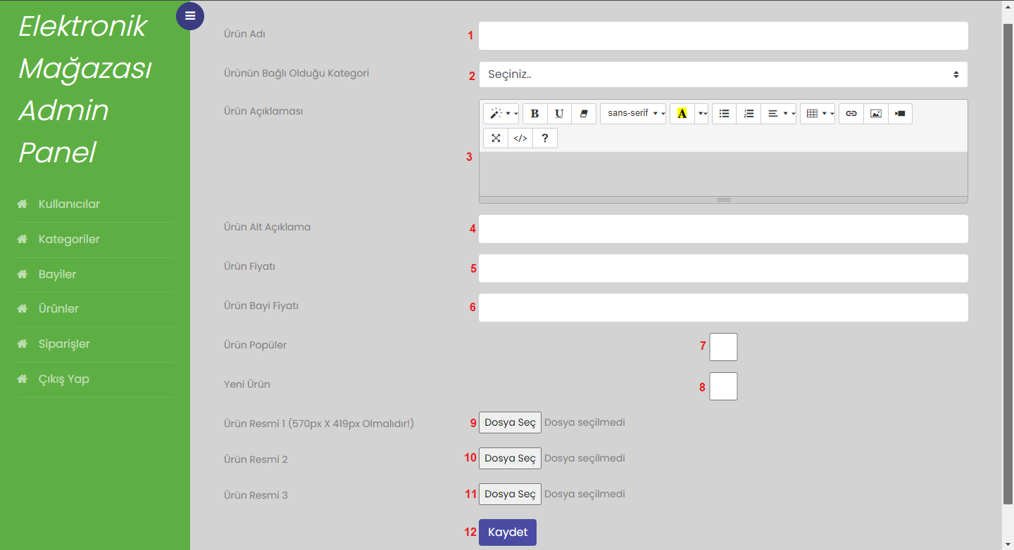 Figure 7.2 Admin Panel New Products Add Page

V. Orders

The orders page is a page that details all orders placed on the site. Clicking on button 5 in the navbar will take you to the orders page (figure 8.1). This page contains all orders and has filters to filter orders. Input 1 filters orders by trader code, inputs 2 and 3 filter orders by date range, input 4 applies the filters. Button 5 opens the order details page (Figure 8.2) , there is 1 input field on the order details page, this field filters by product name.

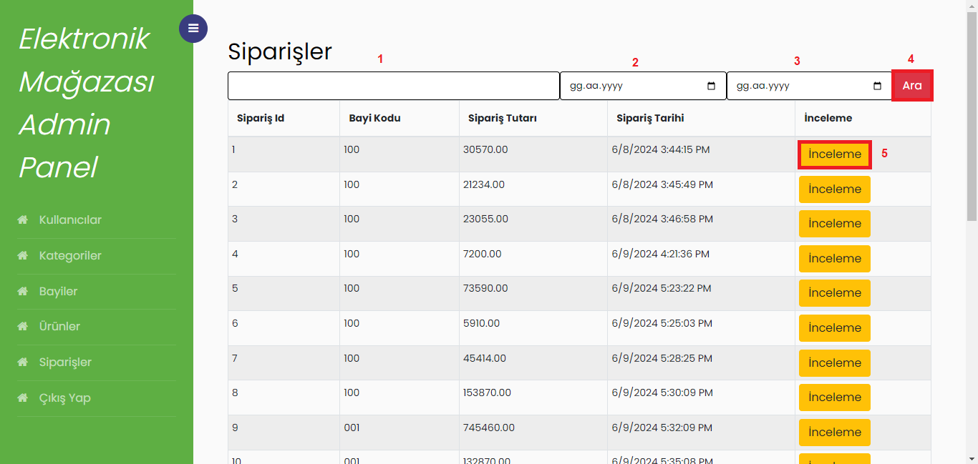 Figure 8.1 Admin Panel Orders Page

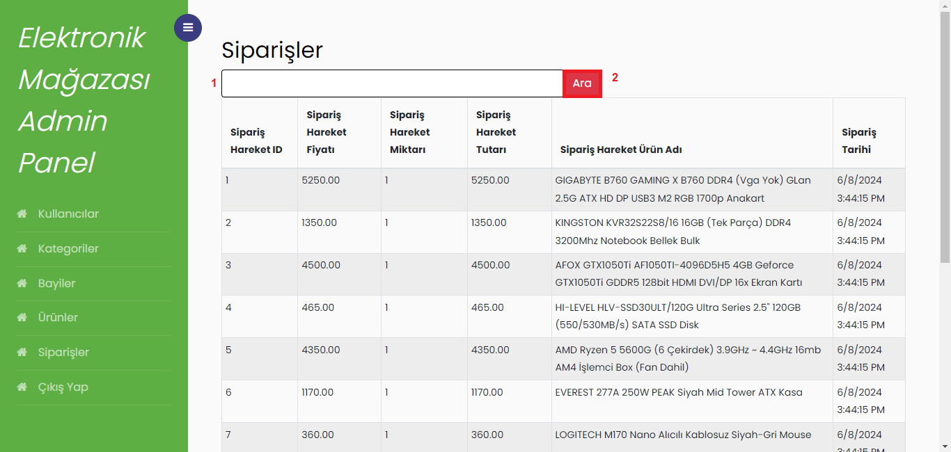

Figure 8.2 Admin Panel Order Detail Page

VI. Reports

The categories of products sold on the site over the past month, along with the user who spent the most, can be found in tab 6 (Figure 9.1) of the navigation bar, which leads to the reports page. The initial report illustrates the ten categories with the highest sales on the site over the past month.

The second report on this page (Figure 9.2) presents the users who have spent the most on the site. Both reports are presented in the form of pie charts, with Chart.js employed in both instances. Further details can be accessed by examining the relevant section of the chart.

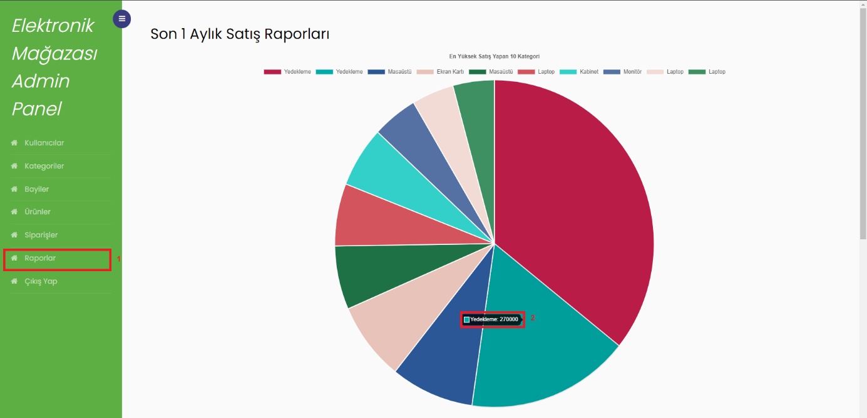 Figure 9.1 Admin Panel Reports Page

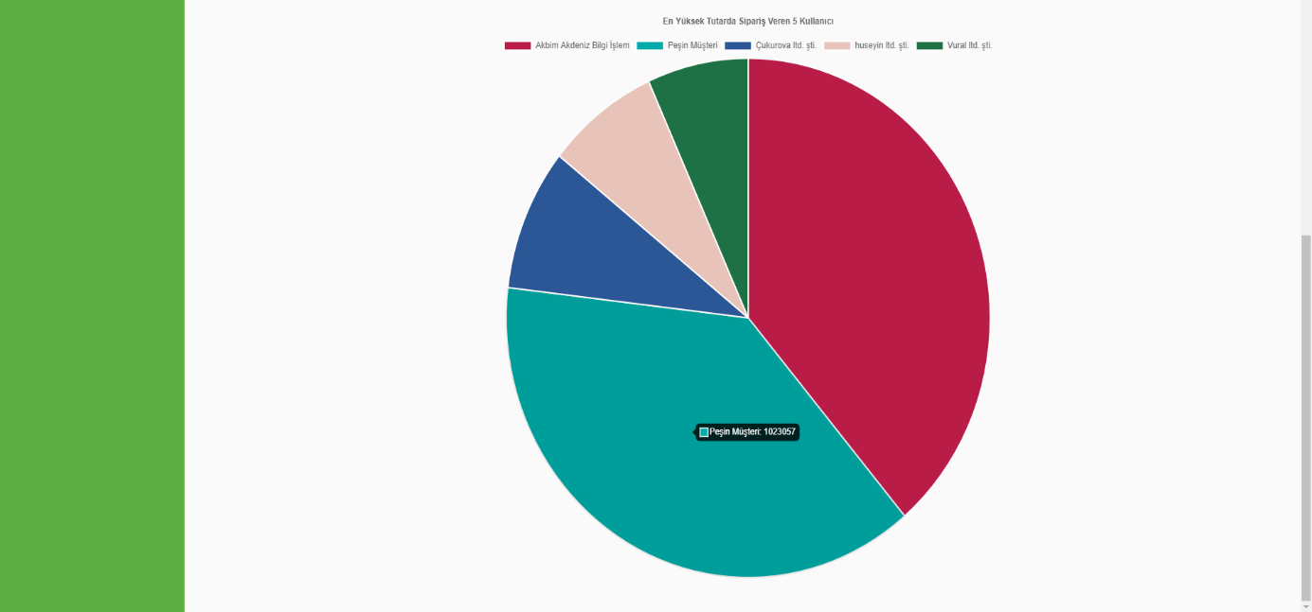 Figure 9.2 Admin Panel Report Page 2

3 Uploading Data And Activating The Site

After the site was completed, we uploaded the data to our site using the admin panel and performed debugging operations by placing various orders. When the site was working smoothly, we published it on the Internet and our site worked at tez.dinamikyazilimdeneme.com.tr during the thesis presentation.

Thanks To

We would like to express our gratitude to all those who assisted us in this project, in particular Kaan Kandemir and Recep Özkan Yikmış.

References

<https://sweetalert2.github.io/>

<https://www.gunes.net/>

<https://www.free-css.com/free-css-templates/page280/multishop>